CAPSTONE PROJECT DOCUMENTATION
PROJECT 2—AUTH0 IMPLEMENTATION:
1) Applications Page
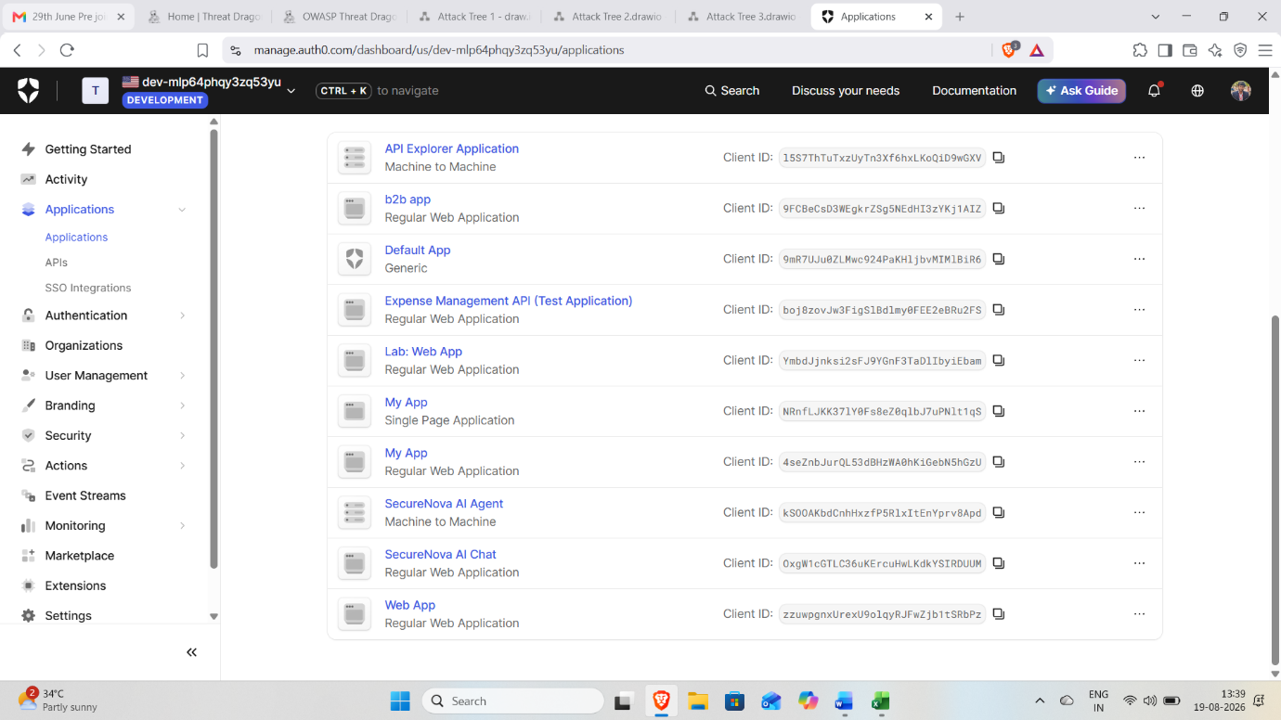
Shows the Regular Web Application and SecureNova AI Agent M2M application successfully registered in Auth0.
2) API Configuration
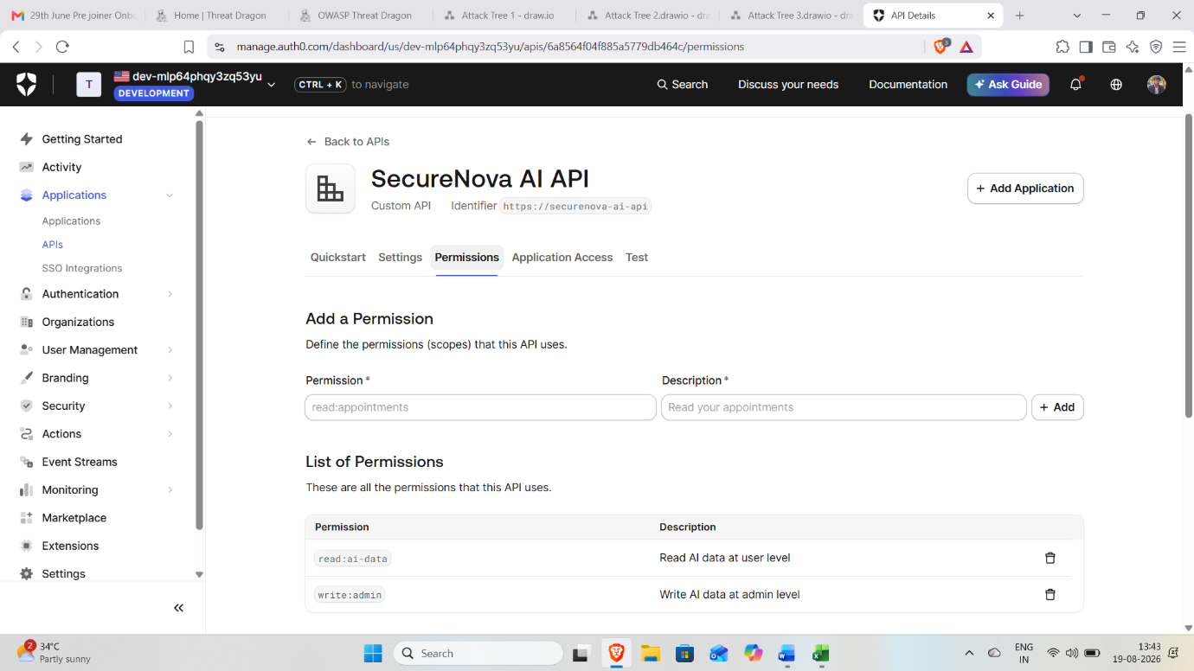
Shows the SecureNova AI API configured with the custom scopes read:ai-data and write:admin.
3) JWT Token Validation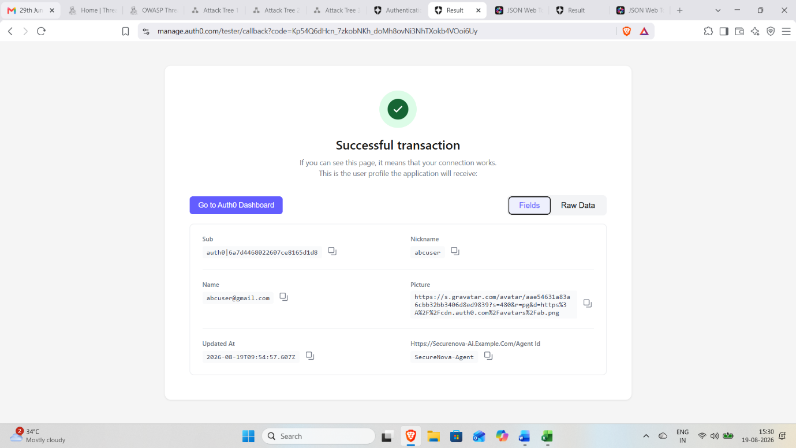
After the transcation successful then move to the jwt.io and then decode the payload values

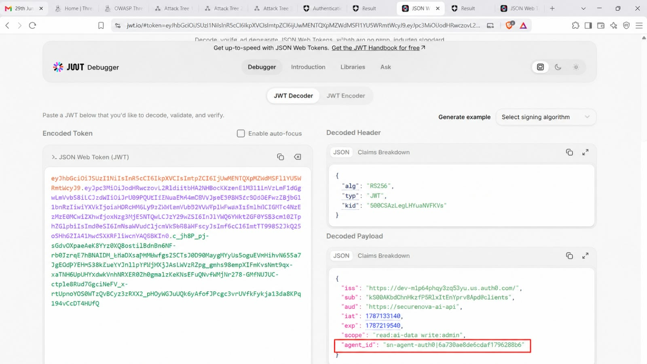
Shows the decoded JWT with aud, iss, exp, scope, and the agent_id custom claim.

4) Custom Universal Login
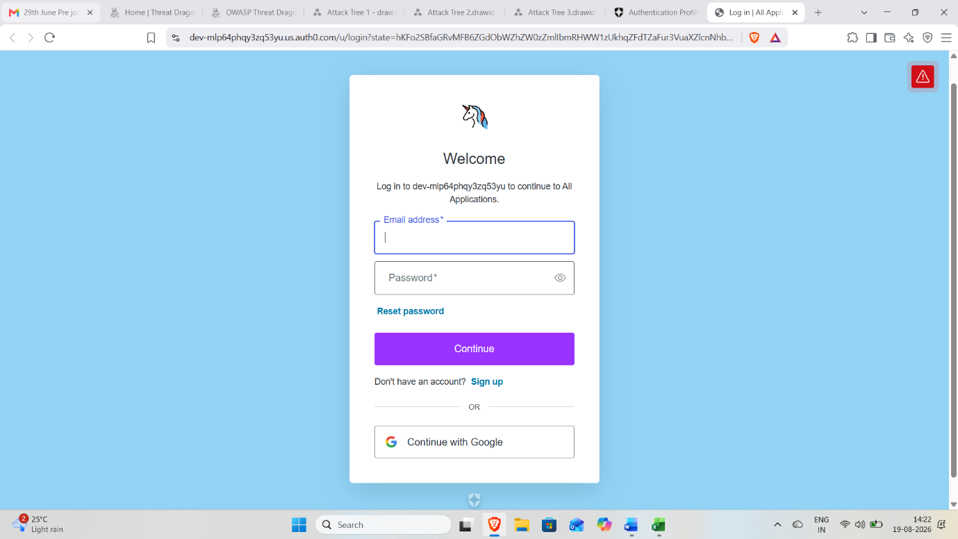
Shows the Auth0 Universal Login page with SecureNova custom branding applied.

5) MFA Protection
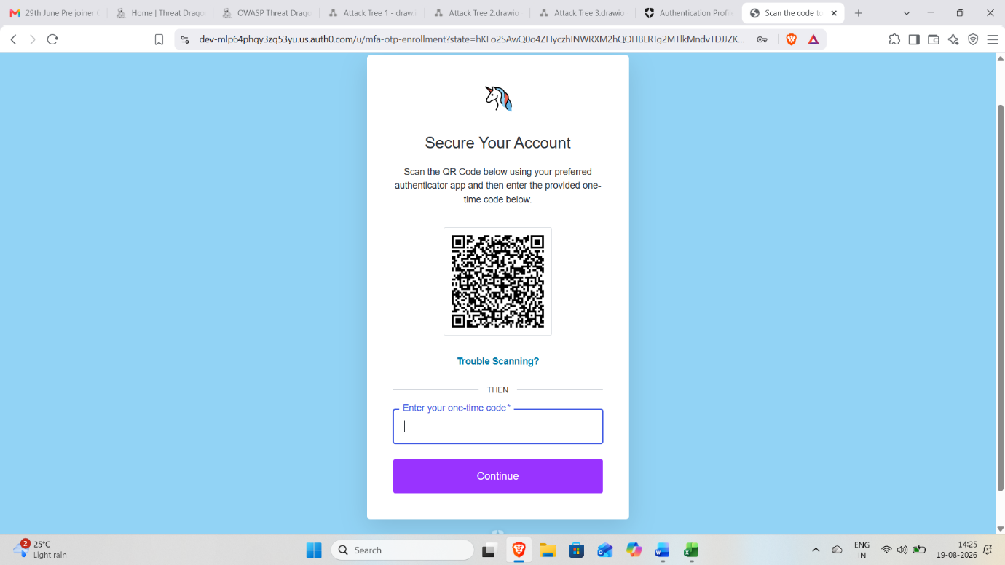
Shows the Auth0 MFA enrollment/TOTP challenge successfully enabled for user authentication.

6)Post-Login Action
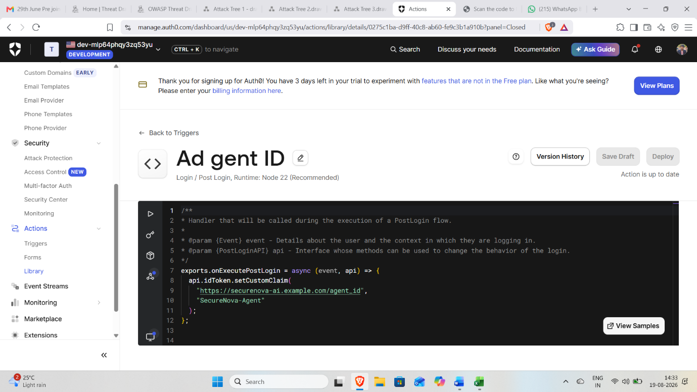
Shows the Auth0 Action code that adds the agent_id custom claim to the authenticated user's token.

7) Attack Protection
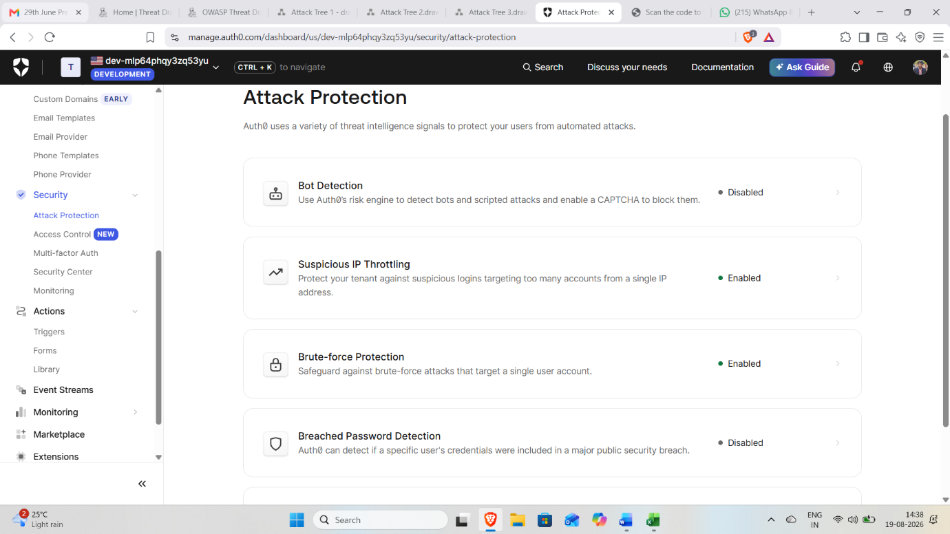
Shows Brute-Force Protection and Suspicious IP Throttling enabled in Auth0.

8) Credential Rotation Test
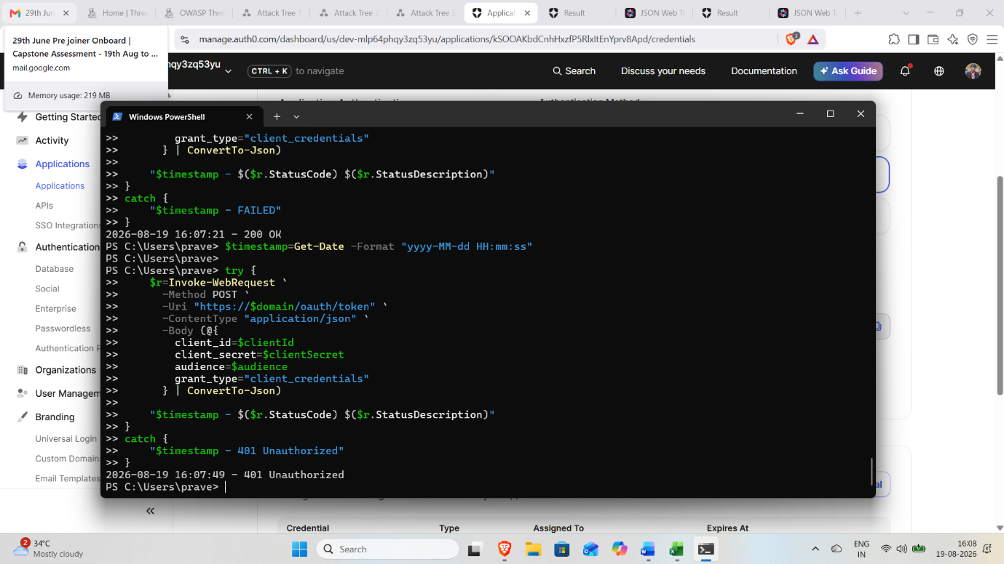
Shows a timestamped 200 OK request followed by 401 Unauthorized when the old credential is replayed after rotation.

